Epidemic Disaster Preparedness and Response Plan

PARBAT HOSPITAL z
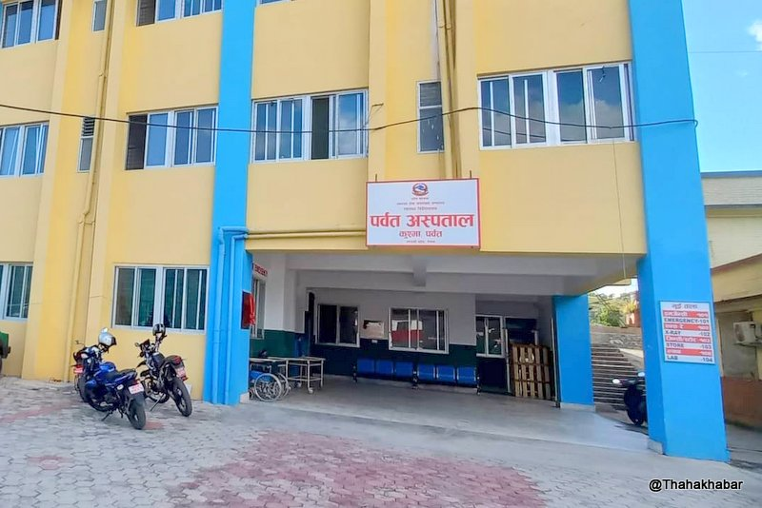
Aug 2024
Parbat , Kushma

Phone No: 067-42-414

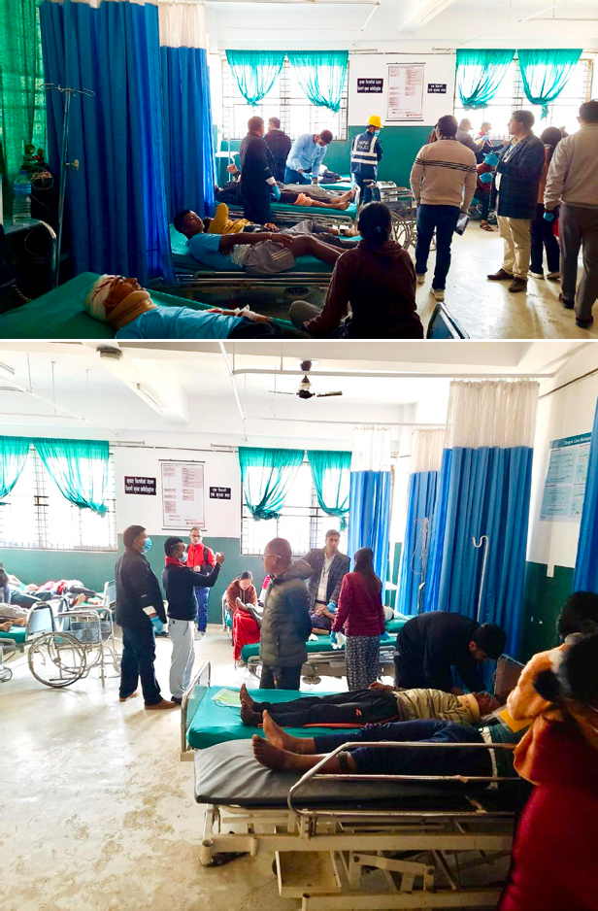
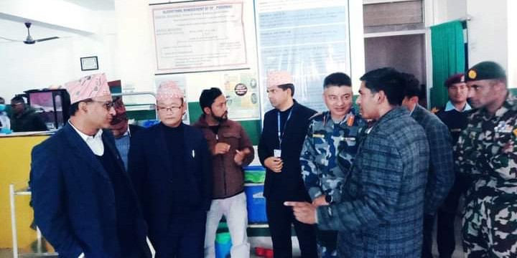
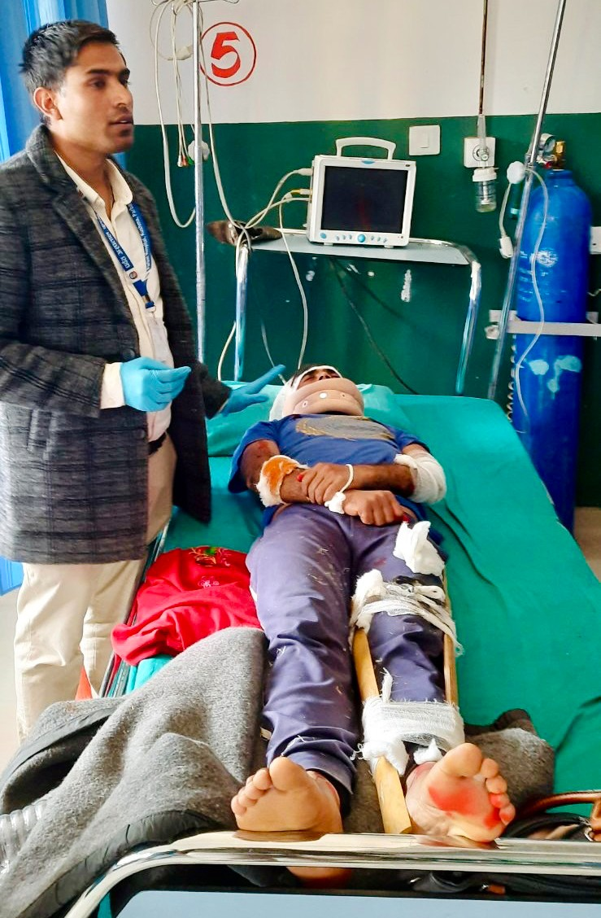
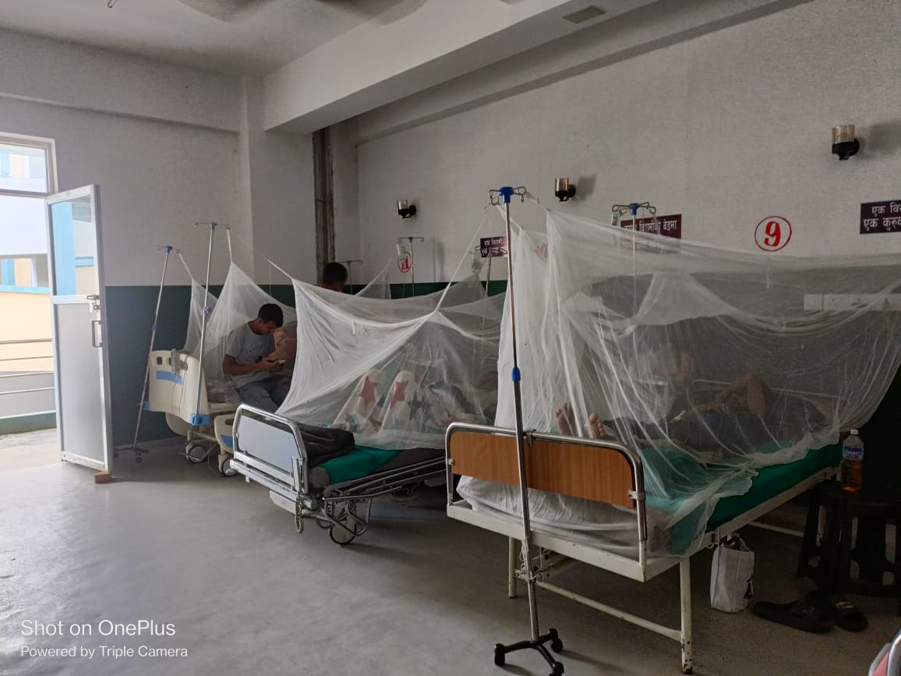

CONTENTS

Epidemic
Epidemic Disaster Response Committee 5
Epidemic Disaster Management Committee (Executive committee) 5
Functions 5
Hospital Incident Command Center 6
Introduction 6
Epidemic Disease Disaster 6
Minor Epidemic Disaster 6
Major Epidemic Disaster 6
Epidemic Disaster Management Plan 6
Activation of Epidemic Disaster Plan 7
Hospital Incident Command System (HICS) 8
Triaging 8
Triage category 8
Triage area: for P1 and P2 (If victim come without notification) 9
Triage officer 9
Triage card 9
Method of triaging 10
START (Simple Triage and Rapid Treatment) 10
Triage and Treatment Areas 10
Triage and Treatment Area during Epidemic Disaster (P3) 11
Teams 11
Crowd control 11
Epidemic Disaster victims 12
Disaster supplies 12
Aftermath 12
Debriefing 12
Management of media and Relatives 12
Management of Media 12
Guidelines for the official spokesperson 12
Proactive approach to media relations for the official spokesperson 13
Management of relatives 13
Referral protocol 13
Appendix – Phone numbers 14
HICC Members 14
Head of departments 14
Authorities and agencies 14
Ambulances 14
Emergency Services 15
Disease Epidemic Disaster Surveillance Committee 15
Hospital capacity 15
Resource Sharing 16
Communication and coordination 18

Epidemic Disaster Response Committee
There will be two committee, executive committee (Epidemic Disaster Management Committee) and Epidemic disaster response committee.
Members:
- Hospital Me Su -Mr. Dr Hemanta Banstola
- Medical Coordinator -Dr. Milan Awale
- MDGP / Doctor -Dr. Santoshi Thapaliya
- Orthopedics / X ray Chief -Mr. Bishal Giri
- Hospital Admistration -Mrs Madan Sharma
- Nursing -Mrs Saraswati Baral
- HOD Anesthesia / Anesthesia - Mr Surya Bam
- MO In-charge -Dr. Sanam Dhakal
- Emergency In-Charge -Mr. Laxman Uphadhya
- Accountant -Mr. Dhan Bahadur Kunwar

Epidemic Disaster Management Committee (Executive committee)
This committee will work on improving the capacity of the hospital to response to epidemic disaster. Members of the committee will be selected or positional as per hospital rules. Name of present members of the committee are as follows.
- Emergency Registrar -Dr Milan Awale
- MO In-charge - Dr. Sanam Dhakal
- Hospital Manager -Mr. Madan Sharma
- Nursing -Mrs. Saraswati Baral
- OT Anesthesia assistent -Mrs. Surya Bam
- Emergency In-Charge - Mr. Dinesh Sha
- X ray In-charge - Mr. Bishal Giri
- Hose Keeping In-Charge - Mr. Rudra Acharya
- Communication Officer -Ms. Laxman Uphadhya
- OPD In-Charge -Mr. Phul K Thapa
- HOD Nursing (Parbat Hospital) -Ms. Saraswati Baral

Functions
- To update the epidemic disaster response plan.
- To ensure all staff have read the epidemic disaster preparedness document.
- To ensure that all new staff have epidemic disaster training.
- To keep the supplies required for epidemic disaster in readiness.
- To liaise with other hospitals/health service providers in coordinating the epidemic disaster response.
- To liaise with health ministry as a part of national epidemic disaster response plan.
- To advise the administration to strengthen the structural and non-structural components of the hospital such that the hospital will continue to function at the time of epidemic disaster.

Hospital Incident Command Center

Incident Commander (Hospital Director)
Dr Hemant Banstola

Operational Officer
(Medical Coordinator)
Dr Milan Awa

Logistic Officer
(Matron)
Saraswati Baral

Planning Officer
(Hospital Manager)
Madan Sharma

Finance Officer
(Accountant)
Dhan Bdr Kunwar
Figure 1: Hospital incident command center

Introduction
“The number of cases indicating the presence of an epidemic varies according to the agent, size and type of population exposed, previous experience or lack of exposure to the disease and time and place of occurrence.” (WHO,2007)

Epidemic Disease Disaster
Epidemic can be defined as "The occurrence in a community or region of cases of an illness, specific health related behavior, or other health related events clearly in excess of normal expectancy.

Minor Epidemic Disaster
LESS THAN 5- Patients (P1 and P2)
- Patient will enter reception and will be attended by on duty Doctor.
- Patient will be managed in a normal way.
- May develop into a Major Disaster.

Major Epidemic Disaster
Over 5 Patients (P3) or (LESS THAN 3 PATIENTS IF ALL ARE RED)
- The decision to declare a “Epidemic Disaster State” should be made by (or in consultation with) incident commander.
- The Receptionist must be instructed to announce the “Epidemic Disaster State” over the loudspeakers, and put on the siren.
- The Epidemic Disaster Plan must be activated.
- The main emergency entrance must be closed, and patients directed to enter via Gate-5, leading to the Triage Area
- The hospital disaster preparedness and response plan will be activated.

Epidemic Disaster Management Plan
- The plan must function day and night.
- During working days (OPD hours: 8am to 5 pm) patients must be directed out of the hospital via exit of RED/YELLOW area (Gate No. 2 and 3) for ER Patient and green area (Gate no: 5) for OPD patient.
- The OPD area will already be clear by OPD staff.
- If there is disaster in off hours, emergency on duty registrar or emergency duty staff or senior nursing staff should inform hospital incident commander.

Activation of Epidemic Disaster Plan
Calling “Epidemic Disaster State”

Information from surveillance Team of Hospital/ Police/ Health Office

Inform ER on Duty MO/ER duty In-charge

On duty Emergency MO /Emergency In-Charge
Verified following information
Type of Infectious Disaster
Estimated number of victims
Estimated severity of cases (ICU vs Ward)

On duty Emergency MO /Emergency on Duty In-Charge
Give verified information to Incident Commander

Incident commander verifies information
“EPIDEMIC DISASTER STATE”

Epidemic Disaster Plan is activated through Reception-Siren

Figure 1: Epidemic Disaster activation plan.

Hospital Incident Command System (HICS)
This is the facility from which the execution of the response operation is managed. It is in Hospital Manager's office. Its main functions are:
- Communication:
  - With the departments of the hospital for information on casualties, manpower and other resources.
  - With other external agencies like police for information on further victims arriving, estimated time of arrivals etc.
  - With other hospitals for possible patient transfer.
- Information processing:
All information received must be analyzed, its effect determined and decisions made.
- Identification of capacity:
It must develop, maintain and display information on current bed status, stretchers, wheel chairs, medicines, transfer facilities etc.
- Resource management: Identification of resources requirement and its sources.
- Management of media inquiry: Must give information to press, develop and post victim manifest and update it from time to time.
- Record keeping: Record of decisions made in HICC and the reason for the decisions should be maintained. (Personnel in the command center are accountable for their decisions and hence the importance of such record keeping.)

Triaging
- Patients must be assessed and triaged (sorted) on arrival at the triage area, and directed to the correct treatment area for their condition.
- It is essential that the triage area is set up and manned in the before main entrance ER of hospital.
- At the triage area, the designated triage officer will rapidly assess the patients, and tag the victims as per the triage categories.

Triage category
Triage categories:
Category | Classification | Treatment area
Red | Immediate care  (life in danger) | ER RED AREA
Yellow | Urgent care  (Serious, but life not in danger) | ER YELLOW AREA
Green | Minor care (Walking wounded)  (cuts and bruises) | OPD GREEN AREA
Black | Dead /Hopeless | MORGUE/NEAR MORGUE
Table 1: Triage category

- Victims already in the hospital at the time of the disaster will need “triaging backwards” in order to make as much space as possible they should be sent to the treatment area that best fits their condition, or else be admitted or discharged.
- Requires two doctors to sign to declare dead, so all suspected dead to be referred. In case of dead declared by community, dead body can be placed temporarily at half way home.

Triage area: for P1 and P2 (If victim come without notification)

OT MInOr
Lubby

Toilet


Triage area

Decontaninati
Black

Gate

Passage
ECG room
Restroom
Doc ON Duity/ Store

Counter /Police Room

Nursing Station

Picture 1: Triage area.

Triage officer
Senior on duty ER MO will be triage officer. In absence of Senior ER MO, Emergency incharge will take the responsibility.

Triage card
The triage card is rectangular card with a plastic sheath with four color squares with a string to go around neck. The color squares can be removed and placed in the front which depicts the victim's triage category.
On the triage card, there is patient number allocated in front of the card. The patient identification to be complete also requires an alphabet in front i.e. R (for red), Y (for yellow), G (for green) and B (for Black). For example, if the patient is category red and the triage card has number 1, he will be R1. This will make it easy for the x-ray and lab staff to prioritize the investigation and will also tell them which area to send the report. In case of change of triage area it will be replaced as R1Y... The first letter is the place where patient is initially and last letter is the place where patient is shifted. The triage number should be mentioned clearly in the patient card initially and immediately after shifted the treatment area.
The triage cards will be collected by nurse -in -charge before patients are discharged. These should be handed over to logistics officer.

Method of triaging

START (Simple Triage and Rapid Treatment)
This allows the triaging personnel to triage the victims in sixty seconds or less. This is done by assessing Respiration, temperature, Perfusion and Mental status.

Steps:
- Asses the patient for ventilatory rate and adequacy of respiration. If the victim is not breathing, check for foreign bodies causing airway obstruction. Do a chin lift or jaw thrust. If this does not initiate ventilatory effect, tag black. If respiratory rate is more than 30 per minute, tag red. If respiratory rate is less than 30, do not tag yet, but asses for perfusion.

- Assess capillary refill for perfusion by pressing nail bed or lips and release. Color should return in less than two seconds. If capillary refill is more than two seconds, tag red. If capillary refill is normal, do not tag yet but assess for mental status. If there is obvious external bleeding, control hemorrhage by pressure.

- Use simple command to assess the mental status like 'open and close your eyes' or 'squeeze my fingers'. If patient is not responding to these commands, tag red. If patient responds well, tag yellow.

- Patients who have only minor illness should be tagged green.

Triage and Treatment Areas
Area | Location | In-charge | Staff from
Triage | In front of OPD | On duty ER | Staff from ER
RED | Inside ER | MDGP or INCHARGE MO | Staff from ER
YELLOW | Outside ER | Senior MO | Staff from GW
GREEN | OPD Waiting /Below Ladder Passage | MO /Dental Surgeon or OPD In-charge | Staff from OPD, Dental,
BLACK | Morgue/Near Morgue | Ward In-charge | WA, HK in-charge

Triage and Treatment Area during Epidemic Disaster (P3)
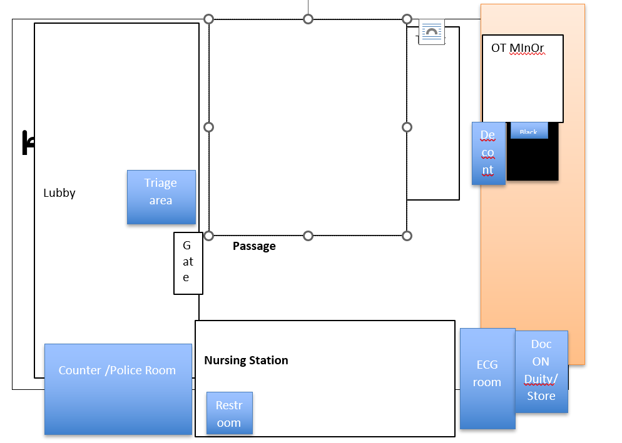

Teams
- There are many “teams” of people taking part in the disaster plan.

- Each team needs a “captain” to ensure all the jobs on his team’s checklist get done. Ideally the captain should be a department head, but he/she may not be immediately available. Therefore a deputy (or anybody) from that team should assume the team captain’s role immediately, and pass the job over to a more senior person, if available, later.

- Each team has a “team clipboard” which defines the role and jobs of that team. There are boxes to be ticked when jobs have been done. These team clipboards are located in a special rack in the Major Incident Box located at Emergency Room. So, when you arrive in the hospital, first see if your team’s clipboard has been taken. If not, you must take the clipboard, and assume the team captain’s role

Crowd control
- Is crucial because once the hospital is over-run it is impossible to work.
- Ideally the crowds are prevented from entering the clinical areas.
- In an “evolving epidemic disaster” or where no prior warning is given, the crowds often get inside the clinical areas from the start. In this case they must be gently but firmly removed.
- Certain doors must be opened or closed by security/administration, and all access points posted with guards.
- Each patient is allowed to enter the primary and secondary triage area with one friend/helper.

Epidemic Disaster victims
- Patients do not pay for tests or treatment initially, but the costing should be recorded on the card.
- Depending on the type of disease severity may need to be kept at area “yellow” for ongoing treatment.
- It is important to clear treatment areas as soon as possible for possible further inflow of victims. Patient should be transferred to wards as soon as possible via Gate .
- Should fill the chare of all patients.
- Green victims should be discharged as soon as possible and victims at other area transferred with priority to those who are in red.

Disaster supplies
- The epidemic disaster stock should have large amounts of saline, dressings, PPE, mask, Gloves, Disinfectant, etc.
- Mattresses and disaster supplies are kept in the disaster supply room and need to be brought out in a disaster.

Aftermath
Once the acute phase of disaster is over, a lot of work still needs to be done. Staff should check with their department heads to make sure that there is nothing more to do before leaving.
The hospital command center should declare the epidemic disaster state is over when:
- No further victims are likely to be brought in.
- All patients in area red and yellow have been transferred to the ward (isolation ward).
- All patients in green area have been discharged.

Debriefing
A hot debriefing will be conducted in the conference room as soon as the epidemic disaster state is over.
A cold debriefing will be conducted within a period of two weeks after the disaster in the grand round. This will be conducted by the hospital director.

Management of media and Relatives

Management of Media
The media person will be informed timely at main gate no 5. Media person with identity card will be allowed to enter through main gate. They will not be allowed to enter other area of hospital. In all possible condition timing of press releases and place should be informed to security at door and if possible it should be printed and posted in the front main gate. Media will be addressed at parking area.

Guidelines for the official spokesperson
- Do not give names of the dead until next of kin have been officially notified.
- Avoid speculation and personal opinion.
- Always tell the truth. If you do not know the answer to a question, admit it.
- Prepare a brief written statement about the situation and provide it to media representatives (include background information, photographs, and audiotapes or videotapes if appropriate).
- Do not give exclusive interviews. Schedule a press conference with all the media representatives and give them all the same information at the same time. If you are going to read a prepared statement and not answer questions until later, say so at the beginning of the conference.
- Be as accessible as possible to take follow-up questions from the media so they don’t think you are avoiding them.
- Stay calm.

Proactive approach to media relations for the official spokesperson
- Do not wait for the media representatives to contact you. Study the patterns and type of reporting done in your area and determine which media seem to be the best informed, the most responsible, and the most effective, and contact them. Begin with one representative and contact others after you have gained some experience.
- Write and state clearly and consistently not only the facts, but the message you want to convey.
- Explain in each interview the importance of the issues you have discussed and how they fit into the general context of public health practices.
- Do what you can to maintain an image of sincerity, experience, and candor.
- Respond to the media when they contact you. They remember who helps them and who does not.

Management of relatives
- List of patient will be listed out at the Mass casualty information board.

Referral protocol
Unavailability of Services
    - Orthopedics
    - Surgery Laparatomy
    - Vascular surgery
    - Cardiothoracic
    - Burn & Plastic Surgery
    - Opthalmology
    - Maxilofacial Surgery
    - CT and MRI
    - Specific test and investigation

Appendix – Phone numbers

HICC Members
Position | Name | Phone number
IC | Hemanta Banstola | 985762119
OD | Dr Milan Awale | 9851278662
Logistic Officer | Mr Rudra Prasad Acharya | 9867847749
Planning Officer | Mr Prakash Subedi | 9840133221
Finance Officer | Dhan Bdr Kunwar | 9857630784
Communication Officer | Mr. Laxman Uphadhya | 9856048892
Security Officer | Mr Sailendra Pausel | 9867916073

Head of departments

Position | Name | Phone number
ER In-charge | Mr. Laxman Uphadhya | 9856048892
Ward | Sarswati Baral | 985365624
Operation Theater | Sarswati Baral | 985365624
Dialysis | Ritu Sapkota | 9865131534
Radiology | Bishgal giri | 9856084560
Lab | Srijan Bhatrtrai | 9847007563
Nutrition | Sarswati pathak | 9860689036

Authorities and agencies
Position | Name | Phone number
HEOC | Mr. Madurji Dhakal
Police Constable | Mr. Ful kumar Thapa | 9857690120
Security In-charge | Mr Shailendra | 9867916073

Ambulances
Name of Hospital | Position | Phone number
Dhaulagiri Hospital | Baglung
Redcross | Driver | 9849595046
Parbat hospital | Ambulence | 9863418536

Emergency Services

Name | Address | Phone Number
Police | Parbat | 100, 985-7630551
Fire Brigade | Parbat | 101,
Blood Bank | Redcross Parbat | 9857622718  Rudra Rimal

Disease Epidemic Disaster Surveillance Committee
Position | Name | Phone Number
Hospital Manager | Laxman Upadhya | 9856048892
OT Incharge | Surya Bam | 9868942794
MDGP | Dr Milan Awale | 9851278662
In-charge MO | Dr Sanam Dhakal | 9846659727
Supervisor/Ward In-charge | Saraswati Baral | 985365624
ER In-charge | Laxman Upadhya | 9856048892
OPD In-charge | Rajesh Giri | 9847626180
Communication Officer | Laxman Upadhya | 9856048892
HK In-Charge | Rudra Acharya | 9867847749
Driver | Parwane Sarki | 9847704522
HOD Nursing | Sarswati Baral | 985365624

Hospital capacity
- Total number of staff: 98
- Hospital bed: 60
- ICU Bed: 0
- Ventilators: 0
- Water source: Yes
- Water storage: Yes
- Electricity: Yes
- Power Backup: Yes
- Alternative backup: No
- Ambulance:1
- Food stock: No Food Stock
- Sanitation: safety tank which drains into local sewage system

Resource Sharing
S.N. | Hospital | Can Contribute | Need Help | Hub Role
1. | Dhaulagiri Hopsital | Blood Bank  OT Room (1)  Patient Ward (20 pts)  Ambulance (1)  ICU Beds-3  Nursing students-20 | Physician/MO  Anesthesia  Orthopedic  Logistics  CT scan | Use blood bank  Water supply  MO student mobilize  surgeon

APPENDIX -I
Parbat Hospital
Kushma Parbat
Mass Casually Information Center
Event: …………………………………… Date: ……………….......
S.N | Name of Patient | Age | Sex | Address | Triage | Remarks

Communication and coordination

Parbat Hospital

Manipal Hospital

GMC

Falabas Nagar

Beni Hopital

Matrishishu

ICDH

Dhaulagiri

PoAHS
Hospital

List of Planning officer and Runner with contact details
SN | Name of hospital | Planning officer (Name) | Designation  (In Hospital) | Contact no
1 | Dhaulagiri Hospital | Dr Amit Dhungana | Disaster Focal persom | 9846199812
2 | ICDH | Dr Bikash Guchan | Director | 9851242341
3 | PoAHS , WRH | Dr Santosh Baniya | ER Incharge
4 | Matrishishu | Dr Dharma | ME Su | 9851206809
5 | Beni Hospital | Dr Anju | ME Su | 9846840738

EPIDEMIC DISASTER MANAGEMENT AND TRIAGE SYSTEM
TRIAGE
In-front of ER Gate
Triage By Triage Officer
MO
from GW -1

BLACK ZONE
Morgue/Near Morgue
RED ZONE
Emergency RED area

AREA HEAD
MDGP or INCHARGE MO

Staffs from

YELLOW ZONE
Emergency YELLOW area

AREA HEAD
Senior MO/Gynecologist

Staffs from

GREEN ZONE
OPD area

AREA HEAD
MO or Dental Surgeon or OPD In-charge

Staffs from

